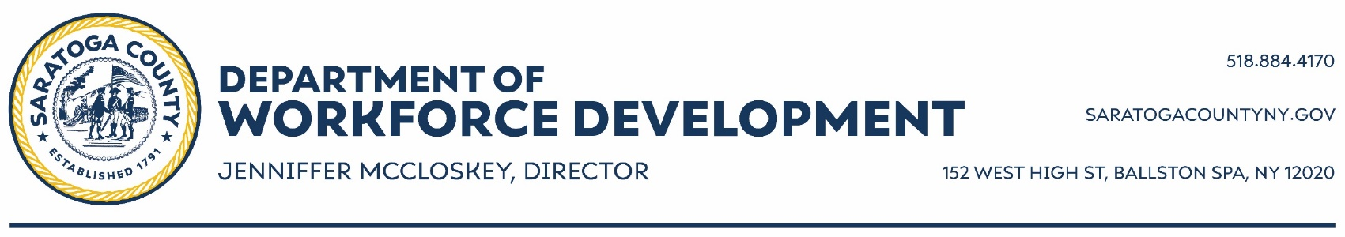

Summer Youth Employment Program (SYEP) Application 2024

Fill out ALL sections of application or your application will not be considered.

Youth Information

Full Legal Name Birthdate

Preferred First Name Social Security Number
Current Age Gender Identity Assigned Sex Preferred Pronouns
Ethnicity, check all that apply q White qBlack q Hispanic qAsian qNative American q Pacific Islander
q Other qPrefer to not answer
Address City Zip code
Do you live in a town different from mailing address? qNo qYes
Youth Cell Youth Email
Preferred contact qCall qText qEmail

Parent Information
Parent/Guardian Name Cell

Youth Interests
What kind of jobs would you be interested in? (Check all that apply) qClerical/Office q Laborer q With youth qCleaning q Library qMuseum qIndoors qOutdoors qWith animals qOther

Select any skills/experiences you wish to gain this summer.

Financial
q Learn to manage money/budget qHow to buy a car qHow to open a bank account qAll about credit
qStudent loans qFinancing college

Soft Skills
qTime management qCommunication qResolving workplace conflict qNetworking qTeamwork
qCreative thinking qWork ethic qListening

Occupational Skills
qCoding qClerical work (paperwork, answering phones qLandscaping qMaintenance qComputer skills qFood preparation qRetail qFood Service
Availability
Do you have a valid Employment Certificate (green/blue work card)? q No q Yes
Will you have reliable transportation? q No q Yes
Do you have any known summer commitments?
qNo qYes, what and when
Possibility of Summer School? qNo qYes
Mark days of the week you are available to work
qMonday qTuesday qWednesday qThursday qFriday qSaturday qSunday
Earliest arrival time Latest Departure time

Education
Are you currently enrolled in school?
qNo, last grade completed
qYes, Name of School Current Grade
Do you have an IEP? q No q Yes
Employment History
Have you ever been in the Summer Youth Program? qYes qNo
Have you ever worked/volunteered before? qNo, skip to next page qYes, complete work history below
Employer Start Date
Address End Date
Job Title Wage q Hour q Week q Month qYear
Reason for Leaving
Job Responsibilities

Employer Start Date
Address End Date
Job Title Wage q Hour q Week q Month qYear
Reason for Leaving
Job Responsibilities

Eligibility
If you are a male, 18 years old or older, have you registered with selective service?qNo qYes
Does youth applicant participate in any of the following programs? qSNAP qHEAP qMedicaid qSSI qTANF qFamily Assistance/Safety Net q Foster Care

Complete this section only if youth applicant does not participate in the listed programs.
List all immediate family members of your household, including youth, and their gross income (income before taxes and deductions).
TYPES OF INCOME
Wages, social security benefits, public assistance benefits, child support, alimony, etc.

Any questions regarding income, please contact the Career Center 518-884-4170.

IMMEDIATE FAMILY MEMBERS CLARIFICATION:
Family members include your mother, father, stepmother, stepfather, any brothers or sisters (including half-siblings) who are under 18 years of age (or 18 and in secondary school) and these siblings’ parents. If you have a child of your own, you should include that child, any brothers or sisters of the child, and the child’s parent. You should not include any of these people if they do not live with you. You should not include other family members such as grandparents, uncles or aunts. If you are married, you should include your spouse, but do not need to include your parents or siblings.

Name | Income Source: Wages, Social Security, etc. | Amount | Received: (Check One)
 |  |  | Yearly | Monthly | Weekly
Certification
I certify that the information on this application is correct to the best of my knowledge. I understand that submitting an application in no way guarantees an interview or placement in a summer job.

Applicant’s Signature Date

The applicant is applying for employment and training services provided by Temporary Assistance for Needy Families (TANF) and/or the State of New York. I will be required to provide certain documentation for eligibility determination. I grant permission to Saratoga County Department of Employment & Training to release and obtain information regarding physical and/or mental disabilities and other pertinent information of a social or economic nature from my child’s school and other appropriate agencies. This information will be used to determine program eligibility and appropriate services to be provided. I understand that all information will be treated as confidential and privileged.
I am a (check one) q Parent q Legal Guardian

Relationship to applicant if guardian

Print Name

Parent/Guardian Signature Date
(Required if applicant is under age 18 or lives at home)

Application Priority Deadline is April 26, 2024
PLEASE RETURN THIS APPLICATION BY MAIL OR E-MAIL TO:

Saratoga County Department of Workforce Development
152 West High Street, Ballston Spa, NY 12020
cstark@saratogacountyny.gov

Questions?
Please call or text us at 518-941-4614.
Calls and text will be returned Monday – Friday 9 am – 3 pm

